**Supporting information for:**

Distribution of PAHs, PCBs, and PCDD/Fs in products from the full-scale pyrolysis of diverse contaminated organic waste

*Erlend Sørmo1,2, Katinka M. Krahn3, Gudny Øyre Flatabø4,5, Thomas Hartnik6, Hans Peter H. Arp1,7, Gerard Cornelissen1,2\**

1. Norwegian Geotechnical Institute (NGI), 0484 Oslo, Norway
2. Norwegian University of Life Sciences (NMBU), 1430 Ås, Norway
3. Lindum AS, 3036 Drammen, Norway
4. VOW ASA, 1384 Asker, Norway
5. University of South-Eastern Norway (USN), 3918 Porsgrunn, Norway
6. Norwegian Institute of Bioeconomy Research (NIBIO), 1433 Ås, Norway
7. Norwegian University of Science and Technology (NTNU), 7491 Trondheim, Norway

*Corresponding author contact details: gerard.cornelissen@ngi.no

Table S.1. PAH, PCDD/F, and PCB congeners analyzed, the respective number of aromatic rings (PAH) or chlorine atoms (PCDD/F and PCB) and toxic equivalency factors (TEF) analyzed in this study.

|  |  |  |  |
| --- | --- | --- | --- |
| **PAH-16** | **Abbreviation** | **Aromatic rings** | **TEF** |
| Naphthalene | Nap | 2 | 0.001 |
| Acenaphthylene | Acy | 3 | 0.001 |
| Acenaphthene | Ace | 3 | 0.001 |
| Fluorene | Flu | 3 | 0.001 |
| Phenanthrene | Phen | 3 | 0.001 |
| Anthracene | Ant | 3 | 0.01 |
| Fluoranthene | Flt | 4 | 0.001 |
| Pyrene | Pyr | 4 | 0.001 |
| Benz(a)anthracene | B(a)A | 4 | 0.1 |
| Chrysene | Cry | 4 | 0.01 |
| Benzo(b)fluoranthene | B(b)F | 5 | 0.1 |
| Benzo(k)fluoranthene | B(k)F | 5 | 0.1 |
| Benzo(a)pyrene | B(a)P | 5 | 1 |
| Indeno(1,2,3-cd)pyrene | IP | 6 | 0.1 |
| Benzo(ghi)perylene | B(ghi)P | 6 | 0.01 |
| Dibenz(ah)anthracene | DB(ah)A | 5 | 1 |
| **PCDD/F-17** | **Abbreviation** | **Chlorines** | **TEF** |
| 2,3,7,8-Tetrachlorodibenzodioxin | 2,3,7,8-TCDD | 4 | 1 |
| 1,2,3,7,8-Pentachlorodibenzodioxin | 1,2,3,7,8-PeCDD | 5 | 1 |
| 1,2,3,4,7,8-Hexachlorodibenxodioxin | 1,2,3,4,7,8-HxCDD | 6 | 0.1 |
| 1,2,3,6,7,8-Hexachlorodibenxodioxin | 1,2,3,6,7,8-HxCDD | 6 | 0.1 |
| 1,2,3,7,8,9-Hexachlorodibenxodioxin | 1,2,3,7,8,9-HxCDD | 6 | 0.1 |
| 1,2,3,4,6,7,8-Heptachlorodibenxodioxin | 1,2,3,4,6,7,8-HpCDD | 7 | 0.01 |
| Octachlorodibenzodioxin | OCDD | 8 | 0.003 |
| 2,3,7,8-Tetrachlorodibenzofuran | 2,3,7,8-TCDF | 4 | 0.1 |
| 1,2,3,7,8-Pentachlorodibenzofuran | 1,2,3,7,8-PeCDF | 5 | 0.05 |
| 2,3,4,7,8-Pentachlorodibenzofuran | 2,3,4,7,8-PeCDF | 5 | 0.5 |
| 1,2,3,4,7,8-Hexachlorodibenzofuran | 1,2,3,4,7,8-HxCDF | 6 | 0.1 |
| 1,2,3,6,7,8-Hexachlorodibenzofuran | 1,2,3,6,7,8-HxCDF | 6 | 0.1 |
| 1,2,3,7,8,9-Hexachlorodibenzofuran | 1,2,3,7,8,9-HxCDF | 6 | 0.1 |
| 2,3,4,6,7,8-Hexachlorodibenzofuran | 2,3,4,6,7,8-HxCDF | 6 | 0.1 |
| 1,2,3,4,6,7,8-Heptachlorodibenzofuran | 1,2,3,4,6,7,8-HpCDF | 7 | 0.01 |
| 1,2,3,4,7,8,9-Heptachlorodibenzofuran | 1,2,3,4,7,8,9-HpCDF | 6 | 0.01 |
| Octachlorodibenzofuran | OCDF | 8 | 0.001 |
| **PCB-7** | **Abbreviation** | **Chlorines** |  |
| 2,4,4'-Trichlorobiphenyl | PCB28 | 3 |  |
| 2,2',5,5'-Tetrachlorobiphenyl | PCB52 | 4 |  |
| 2,2',4,5,5'-Pentachlorobiphenyl | PCB101 | 5 |  |
| 2,2',3,4,4',5'-Hexachlorobiphenyl | PCB138 | 5 |  |
| 2,2',4,4',5,5'-Hexachlorobiphenyl | PCB153 | 6 |  |
| 2,2',3,4,4',5,5'-Heptachlorobiphenyl | PCB180 | 6 |  |
| 2,3',4,4',5-Pentachlorobiphenyl | PCB118 | 7 |  |

Table S.2. Total concentration of PAHs, PCDD/Fs and PCBs in feedstock (F) and biochars produced at various temperatures (500-800 ˚C) and European Biochar Certificate (EBC) limit values.

|  |  |  |  |  |  |  |  |  |  |  |  |
| --- | --- | --- | --- | --- | --- | --- | --- | --- | --- | --- | --- |
| **PAHs (mg/kg)** | | | | | | **PCDD/F (ng/kg)** | | | **PCBs (µg/kg)** | | |
|  | **Temp.** | **∑16 EPA PAH** | **∑16 EPA PAH EBC limit** | **∑8 EFSA PAH** | **∑8 EFSA PAH EBC limit** | **∑17 PCDD/F (TEQ)** | **∑PCDD/F EBC limit** | **∑17 PCDD/F** | **∑7 PCB** | **∑PCB EBC limit** | **∑6 PCB EBC limit** |
| DSS-1 | F | 1.48 ± 0.03 | 6 mg/kg DM  for all EBC  products | 0.52 ± 0.01 | 1 mg/kg DM  (4 mg/kg DM for EBC-BasicMaterials) | 8.3 ± 0.4 | 20 ng/kg I-TEQ OMS | 2011 ± 118 | 21 | 200 µg/kg DM | 10 µg TEQ/kg DM |
| 500 | 18 ± 1 | 3.1 ± 0.09 | n.d. | 2.69 | 1.7 |
| 600 | 22 ± 1 | 1.73 ± 0.07 | n.d. | 2.01 | <LOQ |
| 700 | 7 ± 0.3 | 0.25 ± 0.01 | n.d. | 2.58 | 1.3 |
| 770 | 3.7 ± 0.1 | 0.14 ± 0.01 | n.d. | 0.44 | 0.3 |
| DSS-2 | F | 0.5 ± 0.02 | 0.148 ± 0.004 | 1.78 ± 0.04 | 302 ± 6 | 7.6 ± 0.3 |
| 500 | 37 ± 2 | 2.54 ± 0.08 | 0.03 | 3.31 | 0.6 |
| 600 | 22.9 ± 0.5 | 0.83 ± 0.01 | 0.02 | 2.89 | 0.4 |
| 700 | 5.9 ± 0.5 | 0.17 ± 0.01 | 0.03 | 3.15 | 0.4 |
| 800 | 23 ± 1 | 1.02 ± 0.05 | 0.03 | 2.66 | 0.5 |
| FWR | F | 0.38 ± 0.01 | 0.08 ± 0.004 | 1.18 ± 0.05 | 323 ± 14 | 9.2 ± 0.4 |
| 600 | 9.1 ± 0.5 | 0.22 ± 0.01 | 0.1 | 9.5 |  |
| 800 | 6.7 ± 0.3 | 0.2 ± 0.01 | 0.003 | 0.3 |  |
| LSS | F | 0.98 ± 0.03 | 0.39 ± 0.01 | 3 ± 0.1 | 589 ± 29 | 17 ± 1 |
| 600 | 3.38 ± 0.04 | 0.15 ± 0.01 | n.d. | n.d. | 0.3 |
| 760 | 2.7 ± 0.1 | 0.13 ± 0.01 | n.d. | n.d. | 0.2 |
| WT | F | 5 ± 0.1 | 1.08 ± 0.02 |  |  |  |  |  |  |
| 500 | 2.5 ± 0.1 | 0.16 ± 0.01 |  |  |  |  |  |  |
| 600 | 118 ± 5 | 7.46 ± 0.22 |  |  |  |  |  |  |
| 700 | 21 ± 1 | 0.45 ± 0.01 |  |  |  |  |  |  |
| 800 | 5 ± 0.3 | 0.13 ± 0.01 |  |  |  |  |  |  |
| GW | F | 0.89 ± 0.02 | 0.141 ± 0.005 |  |  |  |  |  |  |
| 500 | 14 ± 1 | 0.54 ± 0.02 |  |  |  |  |  |  |
| 600 | 5 ± 0.2 | 0.31 ± 0.01 |  |  |  |  |  |  |
| 800 | 7.1 ± 0.3 | 0.25 ± 0.01 |  |  |  |  |  |  |
| CWC | F | <LOQ | <LOQ |  |  |  |  |  |  |
| 530 | 9.4 ± 2.5 | 0.39 ± 0.08 |  |  |  |  |  |  |
| 600 | 17 ± 5 | 0.56 ± 0.19 |  |  |  |  |  |  |
| 700 | 6.6 ± 3.4 | 0.23 ± 0.09 |  |  |  |  |  |  |
| 750 | 6.4 ± 0.1 | 0.26 ± 0.02 |  |  |  |  |  |  |

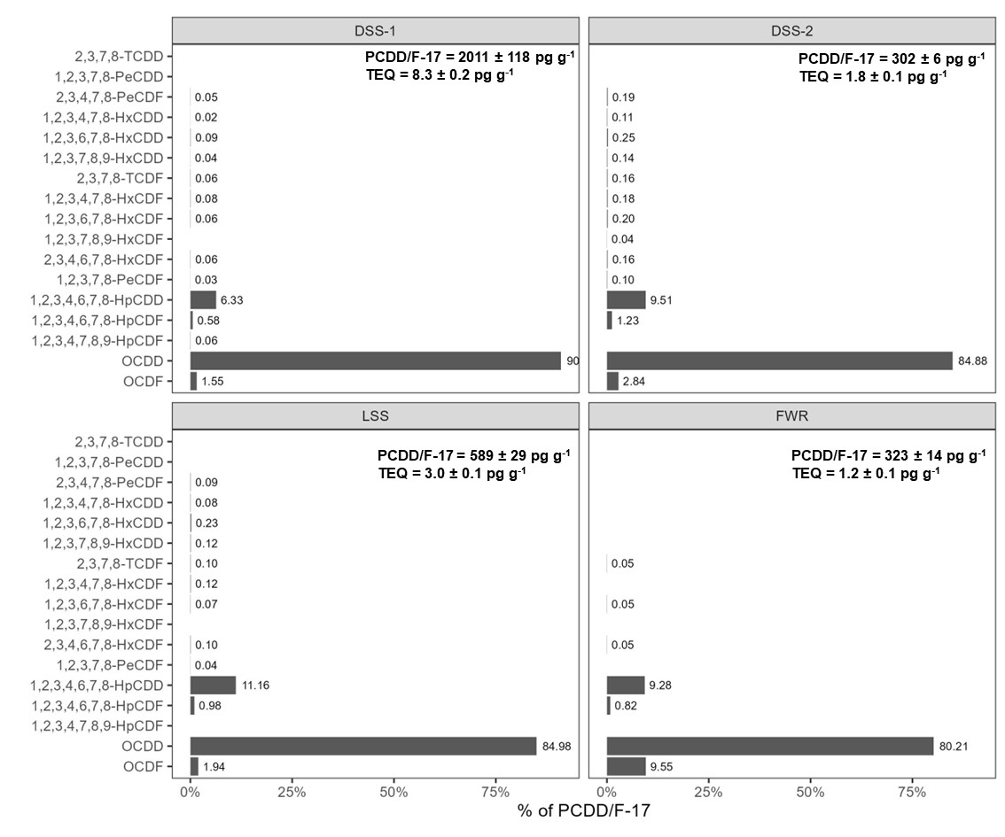

Figure S.1 Total concentration (∑PCDD/F-17, pg g-1), toxic equivalence quotients (TEQ) relative to 2,3,7,8-PCDD, and distribution of dioxins (% of ∑PCDD/F-17) detected in the digested sewage sludges (DSS-1 and DSS-2), limed sewage sludge (LSS), and food waste reject (FWR) prior to pyrolysis, in order of descending TEF.

Figure S.2 Total concentration (ng PCB-7 g-1), and distribution of PCBs (% of PCB-7) detected in the digested sewage sludges (DSS-1 and DSS-2), limed sewage sludge (LSS), and food waste reject (FWR) prior to pyrolysis.

Figure S.3 Total concentration (∑PAH-16 µg g-1), toxic equivalence quotients (TEQ) relative to B(a)P, and distribution of PAHs (% of ∑PAH-16) detected in the digested sewage sludges (DSS-1 and DSS-2), dewatered sewage sludge (DWSS), limed sewage sludge (LSS), food waste reject (FWR), waste timber (WT), garden waste (GW), and wood chips (CWC) prior to pyrolysis.

Table S.3 Change in number of congeners detected in feedstock and the respective biochar products.

|  |  |  |  |  |  |  |  |
| --- | --- | --- | --- | --- | --- | --- | --- |
|  |  | **PCDD/F-17** | | | **PCB-7** | | |
| **Feedstock** | **Pyrolysis temp. (˚C)** | **number of congeners in feedstock** | **number of congeners in biochar** | **% fewer congeners in biochar** | **number of congeners in feedstock** | **number of congeners in biochar** | **% fewer congeners in biochar** |
| DSS-1 | 500 | 14 | 2 | 86 % | 7 | 6 | 14 % |
| 600 | 14 | 3 | 79 % | 7 | 0 | 100 % |
| 700 | 14 | 4 | 71 % | 7 | 5 | 29 % |
| 760 | 14 | 2 | 86 % | 7 | 2 | 71 % |
| DSS-2 | 500 | 14 | 5 | 64 % | 7 | 4 | 43 % |
| 600 | 14 | 4 | 71 % | 7 | 2 | 71 % |
| 700 | 14 | 4 | 71 % | 7 | 3 | 57 % |
| 800 | 14 | 5 | 64 % | 7 | 3 | 57 % |
| FWR | 600 | 7 | 4 | 43 % |  |  |  |
| 800 | 7 | 1 | 86 % |  |  |  |
| LSS | 600 |  |  |  | 7 | 2 | 71 % |
| 760 |  |  |  | 7 | 2 | 71 % |

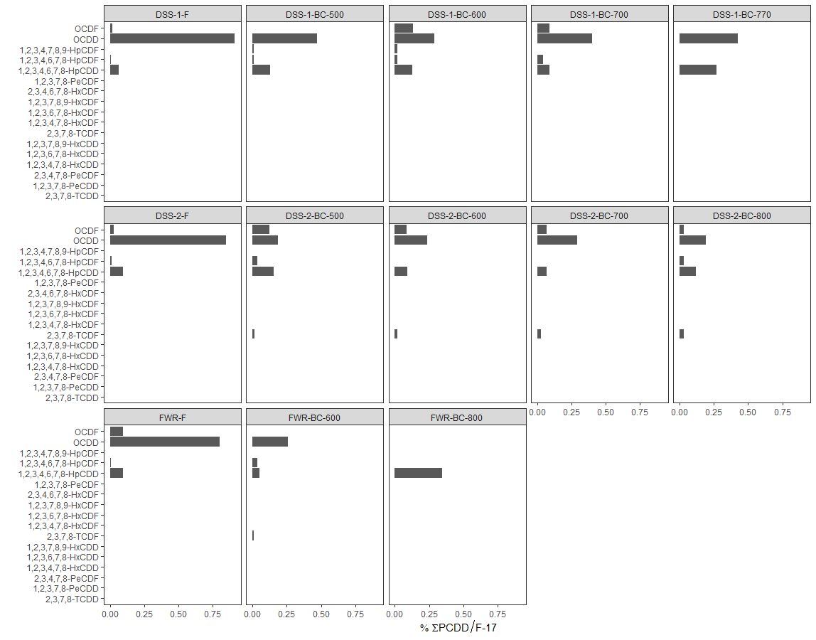

Figure S.4 Distribution of PCDD/Fs (% of ∑PCDD/F-17) in the feedstock (F) and biochars (BC) at different temperatures (500-800 ˚C) for the digested sludge 1 (DSS-1), digested sludge 2 (DSS-2), and food waste reject (FWR).

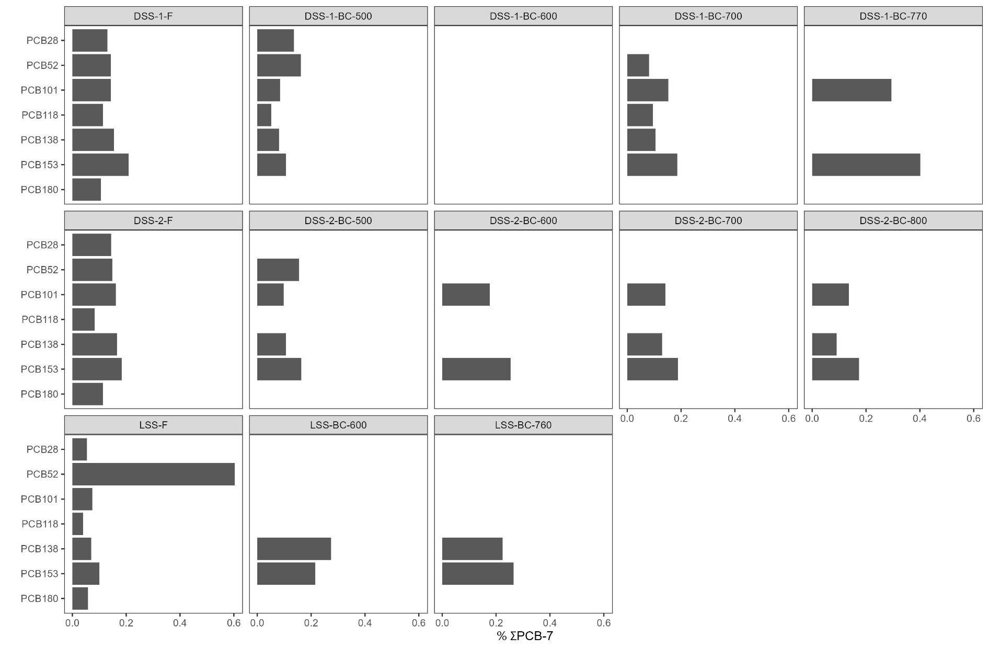

Figure S.5 Distribution of PCBs (% of ∑PCB-7) in the feedstock (F) and biochars (BC) at different temperatures (500-800 ˚C) for the digested sludge 1 (DSS-1), digested sludge 2 (DSS-2), and limed sludge feedstocks (LSS).

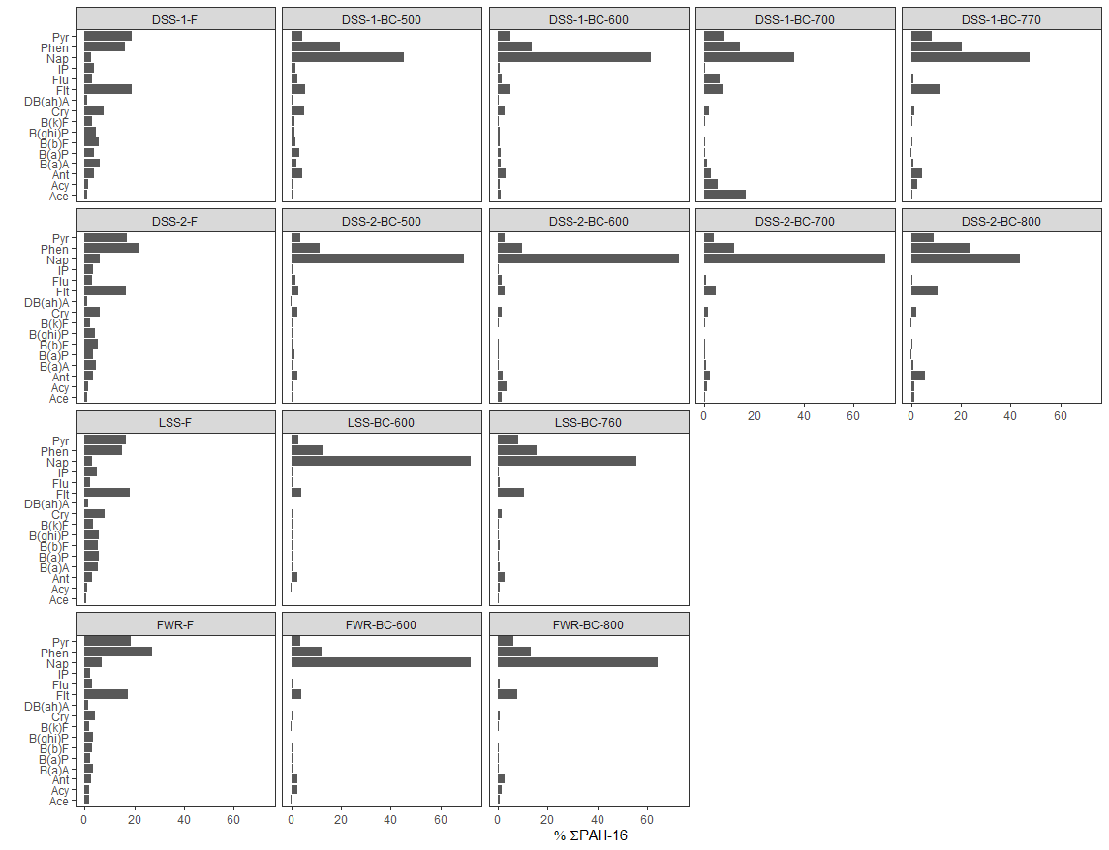

Figure S.6 Distribution of PAHs (% of ∑PAH-16) in the feedstock (F) and biochars (BC) at different temperatures (500-800 ˚C) for the sewage sludge and food waste reject samples.

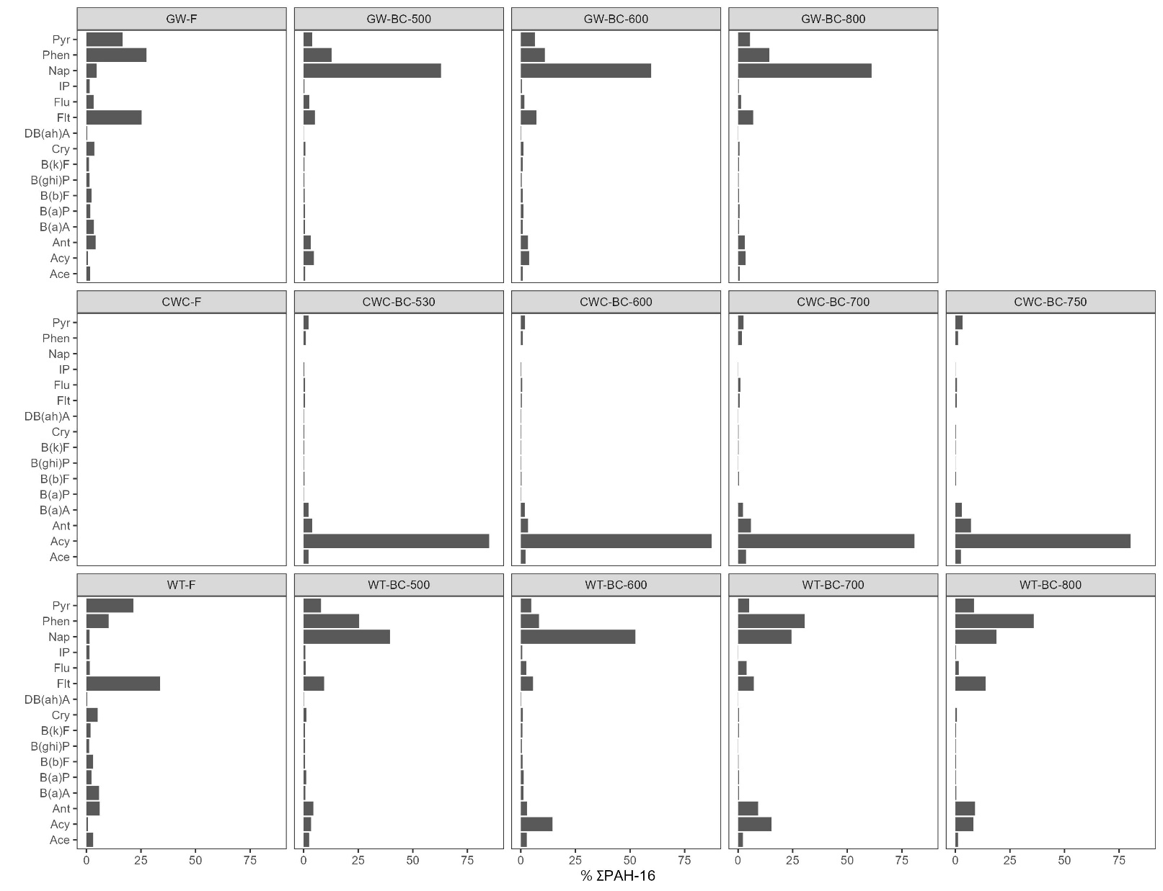

Figure S.4 Distribution of PAHs (% of ∑PAH-16) in the feedstock (F) and biochars (BC) at different temperatures (500-800 ˚C) for the wood-based sample

Table S.4. Pyrolysis product yields, gas sampling volumes and chloride (Cl) content in feedstocks.

|  |  |  |  |  |  |  |  |  |  |  |
| --- | --- | --- | --- | --- | --- | --- | --- | --- | --- | --- |
| **Feedstock** | **Pyrolysis temp. (°C)** | **Yield (%)** | | | **Gas sampling volumes** | | | |  |  |
| **Biochar** | **Oil** | **Gas** | **V_gas_m3** | **V_gas_m3kg** | **V_gas_m3kg_propane** | **V_gas_m3kg_feedstock** | **Cl**  **(g kg-1)** | **S**  **(g kg-1)** |
| CWC | 530 | 18 % | 31 % | 52 % | 2.3 | 101.2 | 647.5 | 18.3 | NA | 0.073 ± 0.003 |
| 600 | 20 % | 32 % | 49 % | 2.3 | 93.2 | 310.9 | 17.8 |
| 700 | 20 % | 27 % | 53 % | 2.3 | 88.9 | 223.7 | 18.0 |
| 750 | 16 % | 13 % | 71 % |  | 120.1 | 303.5 | 17.8 |
| DSS-1 | 500 | 62 % | 21 % | 17 % | 2.1 | 7.6 | 7.6 | 0.6 | 0.24 ± 0.01 | 4.6 ± 0.4 |
| 600 | 58 % | 22 % | 20 % | 1.6 | 10.3 | 10.3 | 5.0 |
| 700 | 62 % | 22 % | 16 % | 2.4 | 6.7 | 6.7 | 4.6 |
| 770 | 70 % | 21 % | 10 % |  | 3.8 | 3.8 | 5.0 |
| DSS-2 | 500 | 52 % | 28 % | 20 % | 1.5 | 12.6 | 12.6 | 4.7 | 0.33 ± 0.08 | 6.9 ± 0.2 |
| 600 | 43 % | 25 % | 32 % | 2.3 | 27.6 | 58.8 | 8.8 |
| 700 | 46 % | 38 % | 16 % | 2.3 | 17.8 | 24.2 | 11.4 |
| 800 | 40 % | 31 % | 29 % | 2.1 | 27.0 | 31.9 | 9.0 |
| FWR | 600 | 35 % | 24 % | 41 % | 2.4 | 37.0 | 44.0 | 12.6 | 2.57 ± 0.15 | 2.47 ± 0.06 |
| 800 | 35 % | 22 % | 43 % | 2.0 | 41.3 | 55.8 | 14.8 |
| GW | 500 | 31 % | 42 % | 27 % | 2.1 | 22.2 | 42.0 | 6.9 | <LOD | 0.49 ± 0.01 |
| 600 | 32 % | 24 % | 44 % |  | 37.6 | 61.5 | 10.2 |
| 800 | 24 % | 23 % | 54 % | 1.3 | 58.0 | 64.0 | 12.1 |
| LSS | 600 | 57 % | 21 % | 22 % | 2.4 | 16.0 | 20.6 | 0.3 | 0.02 ± 0.03 | 5.5 ± 0.1 |
| 760 | 49 % | 19 % | 32 % | 2.4 | 78.9 | 294.4 | 32.1 |
| WT | 500 | 30 % | 48 % | 22 % | 1.9 | 17.2 | 26.2 | 2.3 | 0.01 ± 0.01 | 0.66 ± 0.02 |
| 600 | 27 % | 41 % | 32 % | 2.4 | 29.1 | 44.1 | 6.7 |
| 700 | 21 % | 26 % | 53 % | 1.9 | 66.4 | 91.4 | 12.0 |
| 800 | 18 % | 24 % | 58 % | 1.2 | 73.8 | 79.3 | 12.8 |

Table S.5. Concentration of pollutants in pyrolysis oil.

|  |  |  |  |  |  |  |  |
| --- | --- | --- | --- | --- | --- | --- | --- |
| **Feedstock** | **Pyr.**  **temp. ˚C** | **pollutant class** | **yield** | **Conc. (total)** | **Conc. (TEQ)** | **Conc. (yield corrected)** | **n of congeners detected** |
| CWC | 530 | PAH-16  (mg/kg) | 0.31 | 3871±571 | 28±1.9 | 1191±176 | 16 |
| 600 | 0.32 | 8263 | 67 | 2627 | 16 |
| 700 | 0.27 | 8285 | 56 | 2204 | 16 |
| 750 | 0.13 | 7862±3990 | 107±73 | 1012±514 | 16 |
| DSS-1 | 600 | 0.22 | 4341 | 64 | 946 | 16 |
| 700 | 0.22 | 3591 | 51 | 801 | 16 |
| 770 | 0.21 | 2563 | 39 | 530 | 16 |
| DSS-1 | 600 | PCDD/F-17 (ng/kg) | 0.22 | 1241 | 50 | 270 | 15 |
| DSS-2 | 600 | 0.25 | 120 | 1.8 | 30 | 5 |
| FWR | 800 | 0.22 | 442 | 16 | 99 | 9 |
| DSS-1 | 600 | PCB-7  (µg/kg) | 0.22 | 113 |  | 25 | 7 |
| DSS-2 | 600 | 0.25 | 22 |  | 5 | 7 |
| LSS | 600 | 0.21 | 106 |  | 22 | 7 |

Table S.6 Distribution of ∑PCB-7 in biochar and pyrolysis condensate. Exhaust was not analyzed for PCBs. The distribution is normalized to the amount of feedstock used to produce the corresponding product fractions and normalized for yield of each pyrolysis product. The mass balance deviation is the difference in percent between the total PCB-concentration in the feedstock and the summed concentration in the pyrolysis products to estimate PCB formation/degradation.

|  |  |  |  |  |  |  |  |  |  |  |
| --- | --- | --- | --- | --- | --- | --- | --- | --- | --- | --- |
|  |  | **∑PCB-7 concentration (µg kg-1)** | | | | | **% ∑PCB-7 distribution** | | | **Sum mass balance deviation from feedstock concentration** |
| **Feedstock** | **Pyr. temp. (˚C)** | **feedstock** | **biochar** | **gas** | **oil** | **total** | **biochar** | **gas** | **oil** |
| DSS-1 | 600 | 21 | <LOQ | NA | 24 | 24 | 0.00 % | NA | 100.00 % | + 0.14% |
| DSS-2 | 600 | 7.6 | 0.17 | NA | 5.43 | 5.60 | 3.04 % | NA | 96.96 % | - 74% |
| LSS | 600 | 17 | 0.14 | NA | 22.37 | 22.51 | 0.62 % | NA | 99.38 % | +32% |

Table S.7 PAHs and sum PAH-16 in CWC and DSS-1 condensate at different temperatures (mg kg-1).

|  |  |  |  |  |  |  |  |  |  |
| --- | --- | --- | --- | --- | --- | --- | --- | --- | --- |
|  | **CWC** | | | | | | **DSS-1** | | |
|  | **530** | | **600** | **700** | **750** | | **600** | **700** | **770** |
| Naphthalene | 886 | 1130 | 1880 | 1690 | 361 | 3499 | 2190 | 2010 | 1390 |
| Acenaphthylene | 1560 | 2313 | 4260 | 4740 | 1160 | 5456 | 257 | 219 | 169 |
| Acenaphthene | 62.4 | 84.7 | 152 | 123 | 16.1 | 155 | 73 | 44 | 29.8 |
| Fluorene | 312 | 460 | 859 | 694 | 127 | 1403 | 470 | 303 | 223 |
| Phenanthrene | 178 | 224 | 480 | 456 | 118 | 1300 | 558 | 395 | 297 |
| Anthracene | 56.9 | 73 | 155 | 148 | 38.8 | 464 | 191 | 141 | 98.7 |
| Fluoranthene | 51.6 | 62.3 | 143 | 138 | 43.9 | 425 | 126 | 98.1 | 76.4 |
| Pyrene | 47.7 | 57.6 | 120 | 118 | 39.7 | 390 | 129 | 95.9 | 74 |
| Benz(a)anthracene | 22.6 | 28.1 | 55.2 | 47.1 | 19.1 | 162 | 96.1 | 73.6 | 56.9 |
| Chrysene | 19 | 24.1 | 47.1 | 40.2 | 20.9 | 135 | 145 | 127 | 82.9 |
| Benzo(b)fluoranthene | 8.25 | 9.82 | 22.8 | 18.2 | 11.1 | 60.9 | 26.8 | 22.1 | 17.7 |
| Benzo(k)fluoranthene | 6.65 | 7.44 | 18.4 | 14.6 | 9.61 | 46.9 | 14.4 | 12.1 | 8.65 |
| Benzo(a)pyrene | 15.5 | 18 | 41.2 | 34 | 19.6 | 121 | 36.2 | 28.9 | 22.5 |
| Indeno(1,2,3-cd)pyrene | 5.24 | 5.76 | 14.2 | 11.1 | 7.91 | 51.5 | 13.1 | 10.3 | 8.19 |
| Benzo(ghi)perylene | 3.87 | 4.14 | 10.3 | 8.89 | 7.58 | 40.3 | 9.15 | 7.03 | 5.41 |
| Dibenz(ah)anthracene | 1.64 | 1.94 | 4.42 | 3.41 | 2.17 | 12 | 5.91 | 3.89 | 2.98 |
| **Phase separation** | very low tar | much tar | very low tar | very low tar | very low tar | much tar | none | none | none |
| **∑PAH-16 (mg kg-1)** | **3237** | **4504** | **8263** | **8285** | **2002** | **13722** | **4341** | **3591** | **2563** |
| ∑PAH carcinogenic (mg kg-1) | 79 | 95 | 203 | 169 | 90 | 589 | 338 | 278 | 200 |

Table S.8 PCDD/Fs in condensates (ng TEQ kg-1)

|  |  |  |  |
| --- | --- | --- | --- |
|  | **DSS-1-600** | **DSS-2-600** | **FWR-800** |
| 1,2,3,4,6,7,8-HpCDD | 3.83 | 0.42 | 1.49 |
| 1,2,3,4,6,7,8-HpCDF | 0.11 | 0.03 | 0.03 |
| 1,2,3,4,7,8,9-HpCDF | 0.04 | 0.03 | 0.03 |
| 1,2,3,4,7,8-HxCDD | 2.10 | 0.20 | 0.50 |
| 1,2,3,4,7,8-HxCDF | 0.30 | 0.10 | 0.10 |
| 1,2,3,6,7,8-HxCDD | 4.10 | 0.50 | 1.40 |
| 1,2,3,6,7,8-HxCDF | 0.30 | 0.10 | 0.10 |
| 1,2,3,7,8,9-HxCDD | 4.00 | 0.40 | 1.40 |
| 1,2,3,7,8,9-HxCDF | 0.10 | 0.10 | 0.10 |
| 1,2,3,7,8-PeCDD | 24.00 | 2.00 | 8.00 |
| 1,2,3,7,8-PeCDF | 0.25 | 0.10 | 0.20 |
| 2,3,4,6,7,8-HxCDF | 0.30 | 0.10 | 0.10 |
| 2,3,4,7,8-PeCDF | 2.50 | 1.00 | 1.50 |
| 2,3,7,8-TCDD | 6.00 | 1.00 | 1.00 |
| 2,3,7,8-TCDF | 0.60 | 0.30 | 0.60 |
| OCDD | 2.03 | 0.20 | 0.72 |
| OCDF | 0.02 | 0.01 | 0.01 |

Table S.9 PCBs in condensates (µg kg-1)

|  |  |  |  |
| --- | --- | --- | --- |
|  | **DSS-1-600** | **DSS-2-600** | **LSS-600** |
| PCB101 | 18 | 3 | 19 |
| PCB118 | 10 | 2 | 9 |
| PCB138 | 13 | 2 | 15 |
| PCB153 | 21 | 3 | 23 |
| PCB180 | 11 | 2 | 9 |
| PCB28 | 21 | 6 | 15 |
| PCB52 | 19 | 4 | 16 |

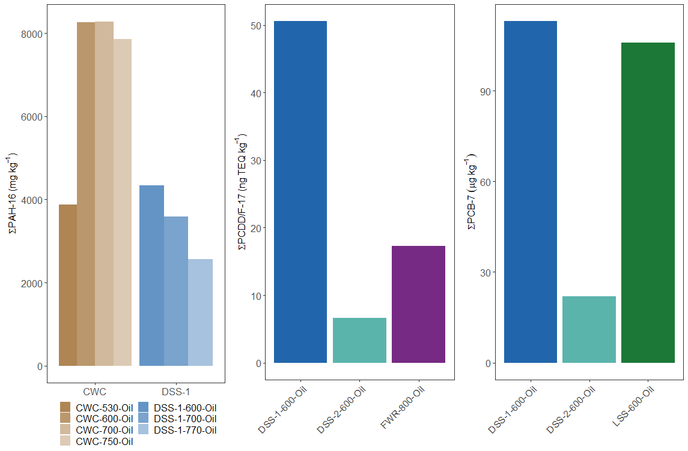

Figure S.1 Pollutant concentration in pyrolysis oil.

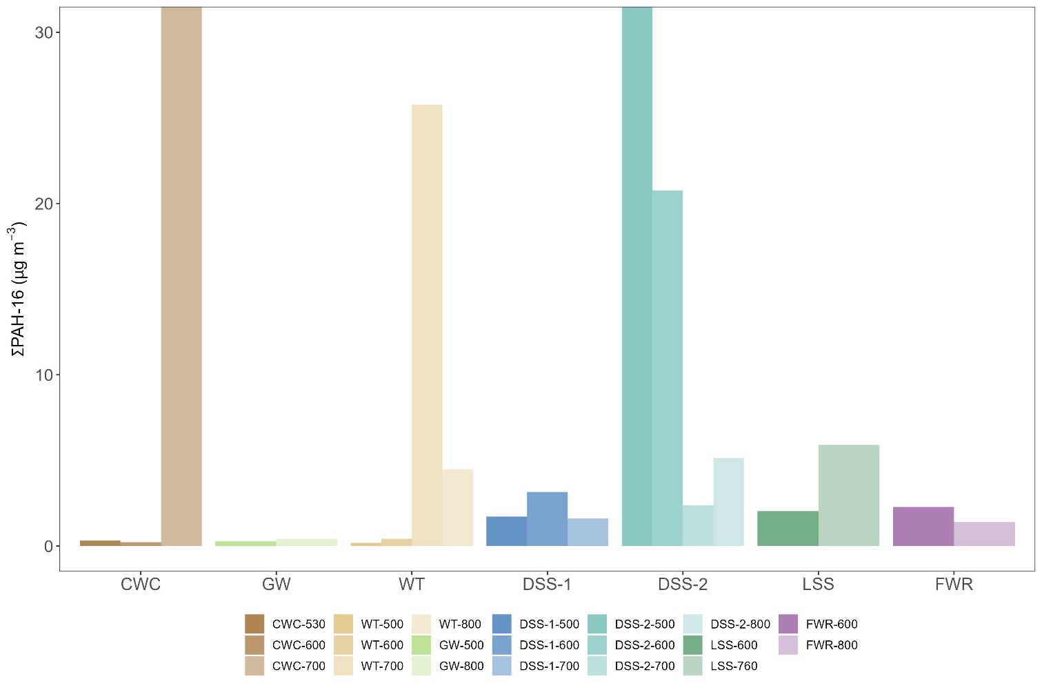

Figure S. 2 PAH concentration in the flue gas.

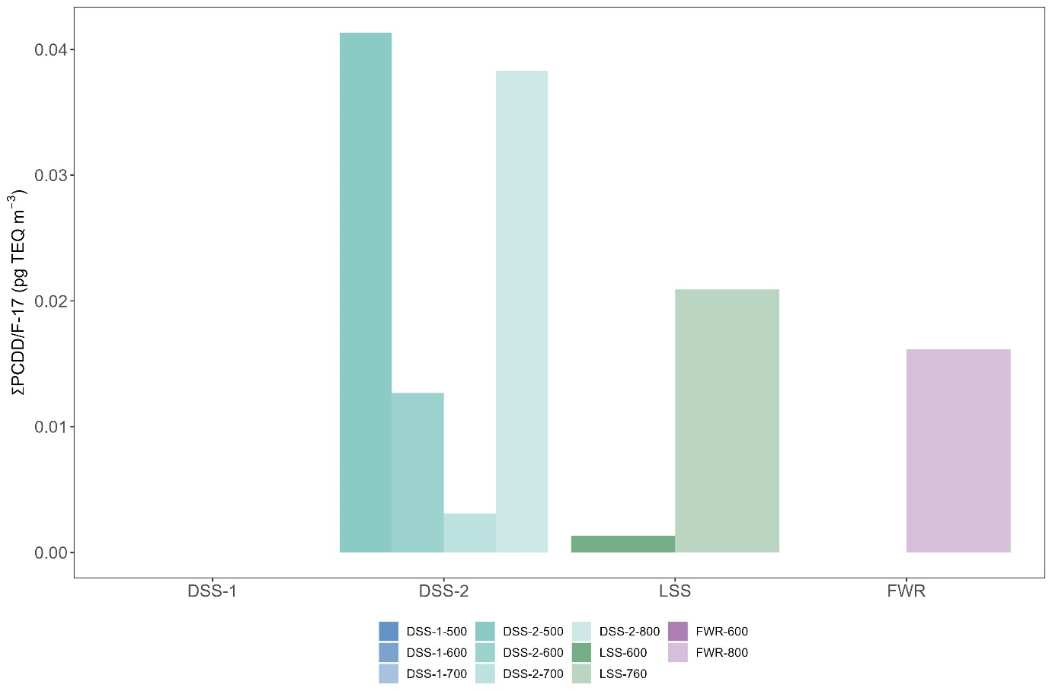

Figure S. 3 PCDD/F-17 concentration in the flue gas.